Student Name: Sahil Hans UID: 25MCI10088
Branch: M.C.A(A.l & M.L) Section/Group: MAM-1 A
Semester: Second Sem Date of Performance:12/01/2026
Subject Name: TECHINCAL SKILLS Subject Code:

WORKSHEET 7
AIM: Implementation of jOINS in PostgreSQL
S/W Requirement: Oracle Database Express Edition and pgAdmin
OBJECTIVES:
- To understand how relational tables are connected using different types of SQL joins.
- To implement INNER, LEFT, RIGHT, and CROSS JOIN operations on multiple tables.
- To analyze relationships between students, courses, and departments using SQL queries.
- To identify unmatched records using LEFT and RIGHT JOIN techniques.
- To explore many-to-many relationships through a bridge (junction) table.
- To generate meaningful insights by combining data from multiple tables.
Practical / Experiment Steps
Step 0 Setup (Creation of Tables)
CREATE TABLE Studentss (
student_id INT PRIMARY KEY,
student_name VARCHAR(50),
department_id INT
);

INSERT INTO Studentss VALUES (1, 'Aman', 101);
INSERT INTO Studentss VALUES (2, 'Sahil', 102);
INSERT INTO Studentss VALUES (3, 'Riya', 101);
INSERT INTO Studentss VALUES (4, 'Karan', NULL);

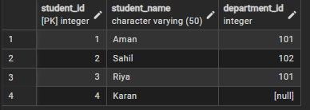

CREATE TABLE Courses (
course_id INT PRIMARY KEY,
course_name VARCHAR(50)
);

INSERT INTO Courses VALUES (201, 'DBMS');
INSERT INTO Courses VALUES (202, 'Machine Learning');
INSERT INTO Courses VALUES (203, 'Operating Systems');

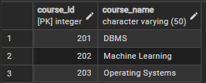

CREATE TABLE Enrollments (
student_id INT,
course_id INT,
PRIMARY KEY (student_id, course_id),
FOREIGN KEY (student_id) REFERENCES Studentss(student_id),
FOREIGN KEY (course_id) REFERENCES Courses(course_id)
);

INSERT INTO Enrollments VALUES (1, 201);
INSERT INTO Enrollments VALUES (1, 202);
INSERT INTO Enrollments VALUES (2, 201);
INSERT INTO Enrollments VALUES (3, 203);

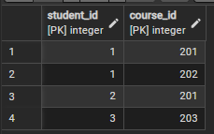

CREATE TABLE Departmentss (
department_id INT PRIMARY KEY,
department_name VARCHAR(50)
);

INSERT INTO Departmentss VALUES (101, 'Computer Science');
INSERT INTO Departmentss VALUES (102, 'Information Technology');
INSERT INTO Departmentss VALUES (103, 'Electronics');

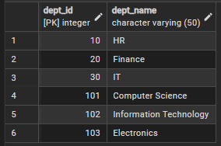

Step 1. Write queries to list students with their enrolled courses (INNER JOIN).

select a.student_name,c.course_name
from Studentss a
inner join Enrollments b on
a.student_id=b.student_id
inner join Courses c on
b.course_id=c.course_id

Output:
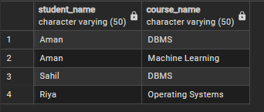
Step 2. Find students not enrolled in any course (LEFT JOIN).

select a.student_name
from Studentss a
left join Enrollments b on
a.student_id=b.student_iD
WHERE course_id is null

Output:
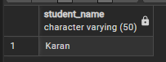

Step 3. Display all courses with or without enrolled students

select DISTINCT a.course_name from
courses a
right join Enrollments b on
a.course_id=b.course_id

Output:
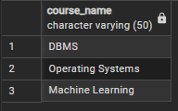

Step 4. Show students with department info using SELF JOIN or multiple joins.

select a.student_name,b.department_id, c.department_name from studentss a
join Studentss b
on a.student_id=b.student_id
join Departmentss c on
b.department_id=c.department_id

Output:
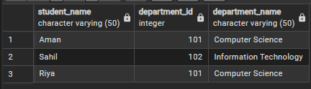

Step 5. Display all possible student-course combinations (CROSS JOIN). (Oracle, SAP, IBM, Microsoft)

select * from Studentss cross join Courses

Output:
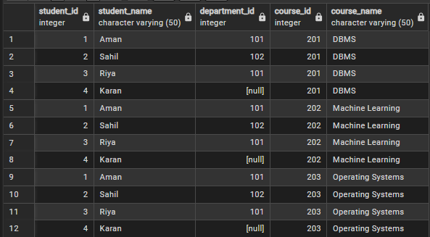

Outcomes:
- Ability to write SQL queries using different types of joins effectively.
- Understanding of how to manage and query relational data across multiple tables.
- Skill in identifying relationships like one-to-many and many-to-many in databases.
- Capability to retrieve both matching and non-matching records using appropriate joins.
- Improved problem-solving skills in designing and querying structured database systems.

